Question(Multi Choice)

You are a system administrator for Microsoft Dynamics CRM Online.

You need to provision a user.

Which two steps should you perform? Each correct answer presents part of the solution.

A. Add the user in the Microsoft Online Services Portal.

B. Configure the user with Read access mode.

C. Enable the user record in Microsoft Dynamics CRM Online.

D. Assign a Microsoft Dynamics CRM Online license to the user.

Answer: A,D

Question(Single Choice)

You install Microsoft Dynamics CRM on-premises.

The installation fails and you receive an installation error.

You need to access the installation log files to view the details about the error.

What should you do?

A. Query the Microsoft Dynamics CRM database and view the log table.

B. View the installation log files in the folder <SystemDrive>'\Program Files\Microsoft Dynamics CRM\Logs.

C. View the installation log files in the folder <SysremDnVe>:\Users\<L/serno/ne>\AppData\Roaming\Microsoft\MSCRM\Logs.

D. View the installation log files by opening the Event Viewer.

Answer: C

Question(Single Choice)

Which action will delete only page Cl?

Refer to the exhibit.



A. Expire replay 2

B. Expire replay 1

C. Expire replay 3

D. Expire replay 4

Answer: B

Question(Single Choice)

In this simulation, you have access to ASDM only. Review the various ASA configurations using ASDMthen answer the five multiple choice questions about the ASA SSLVPN configurations.

To access ASDM, click the ASA icon in the topology diagram.

Note: Not all ASDM functionalities are enabled in this simulation.

Which user authentication method is used when users login to the Clientless SSLVPN portal usinghttps://209.165.201.2/test?

Refer to the topology

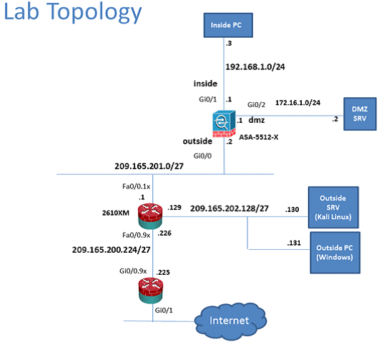

A. AAA with LOCAL database

B. AAA with RADIUS server

C. Certificate

D. Both Certificate and AAA with LOCAL database

E. Both Certificate and AAA with RADIUS server

Answer: A

Question(Single Choice)

Which of the following is the most important characteristic for a supervisor.

Refer to the exhibit

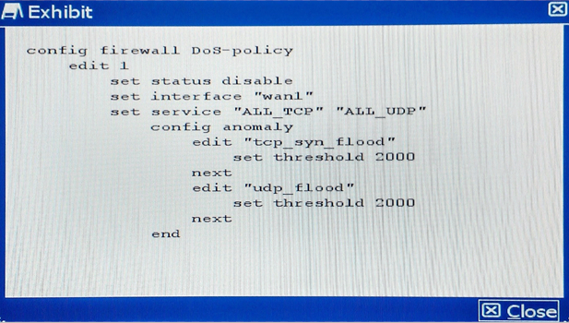

A. Approachable.

B. Qualified.

C. Honest.

D. Believable.

E.Successful.

Answer: C

Explanation: LoremIpsum is simply dummy text of the printing and typesetting industry.

LoremIpsum has been the industry's standard dummy text ever since the 1500s,

when an unknown printer took a galley of type and scrambled it to make a type specimen book.

Question(Multi Choice)

You are a system administrator for Microsoft Dynamics CRM Online.

You need to provision a user.

Which two steps should you perform? Each correct answer presents part of the solution.

A. Add the user in the Microsoft Online Services Portal.

B. Configure the user with Read access mode.

C. Enable the user record in Microsoft Dynamics CRM Online.

D. Assign a Microsoft Dynamics CRM Online license to the user.

Answer: A,D

Explanation: LoremIpsum is simply dummy text of the printing and typesetting industry.

LoremIpsum has been the industry's standard dummy text ever since the 1500s,

when an unknown printer took a galley of type and scrambled it to make a type specimen book.

Question(Single Choice)

You install Microsoft Dynamics CRM on-premises.

The installation fails and you receive an installation error.

You need to access the installation log files to view the details about the error.

What should you do?

Refer to the Scenario

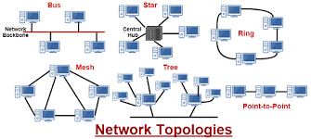

A. Query the Microsoft Dynamics CRM database and view the log table.

B. View the installation log files in the folder <SystemDrive>'\Program Files\Microsoft Dynamics CRM\Logs.

C. View the installation log files in the folder <SysremDnVe>:\Users\<L/serno/ne>\AppData\Roaming\Microsoft\MSCRM\Logs.

D. View the installation log files by opening the Event Viewer.

Answer: C,D

Explanation: LoremIpsum is simply dummy text of the printing and typesetting industry.

LoremIpsum has been the industry's standard dummy text ever since the 1500s,

when an unknown printer took a galley of type and scrambled it to make a type specimen book.

Question(Hotspot)

Select Area on the Image?

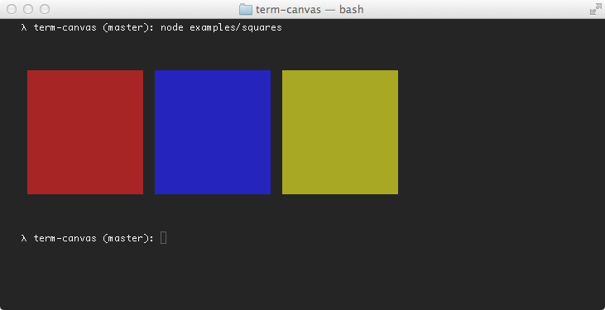

A.33,83,174,236

B.186,85,325,232

C.341,85,479,232

Answer: C

Question(Hotspot)

You have the following code (line numbers are included for reference only):

To answer, complete each statement according to the information presented in the code.

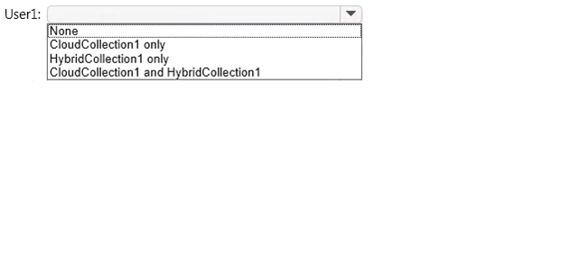

A.50,74,403,89

B.50,56,404,73

C.51,41,401,56

Answer: C